Mr. Sabado, Math 3 Week 4 Wednesday, September 13, 2017

Homework

Due Today:
- Assignment #12
Even/Odd Functions

Due 9/14:
- Assignment #13
Spiral Review #1

Unit 1 Test on Tuesday!!!

Agenda

- Warm-Up
- HW Check

- Notes: Average Rate of Change

- Class Work

- Homework

- Return Graded Work

- Practice Dismissal

Warm-Up

Determine if the following are even, odd, or neither
- $$f(x)=3x^{4}−8x$$

- 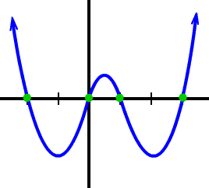

whs.saba.do



“It is never too late to be what you might have been.”
- G. Eliot

