Mr. Sabado, Accounting Week 4 Wednesday, September 13, 2017

Homework

Due Today:
- Assignment #13:
Complete Vocab 1-2 & OYO 1-2

Due 9/14:
- Assignment #14:
Complete Vocab 1-3 & OYO 1-3

Bring your textbook every day!!!

Agenda

- Warm-Up
- Drill 1-D1 Check

- Read: Ch. 1-3 (page 18-20)

- Transactions 6-11
- Class Work

- Homework

- Practice Dismissal

Warm-Up
Write down all of the following:

True or False:
- Prepaid insurance is considered a Liability.

- When two asset accounts are changed in a transaction, there must be an increase and a decrease.

whs.saba.do


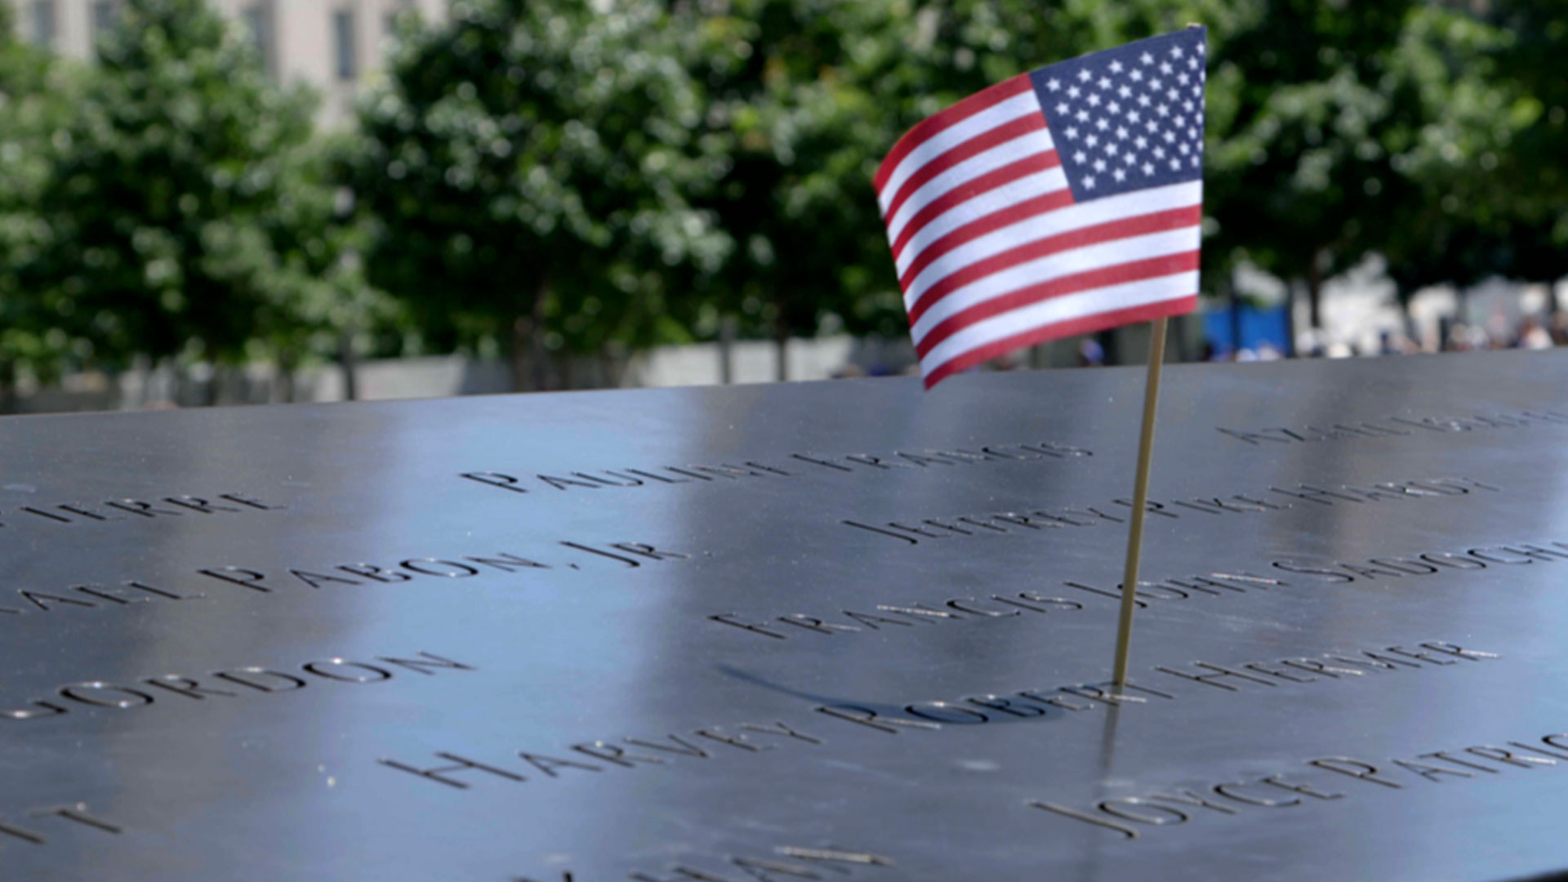

“It is never too late to be what you might have been.”
- G. Eliot

