Mr. Sabado, Accounting Week 16 Friday, December 8, 2017

Homework

Due Today:
A62: Chapter 6 Math Worksheet

Due 12/11
A63: Chapter 6 Activities

Chapter 6 Test on Tuesday, 12/12
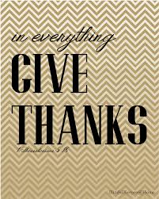

Agenda

- Warm-Up

Class Work: Aplia: Study Guide, Mastery, Challenge Problem

Homework: Chapter 6 Activities

- Return Graded Work

- Return Ch. 1 Study Guide

- Return Chapter 1 Test

Warm-Up

Write “No Warm-Up” in Friday’s box.

Turn in Opener Packet

Pick up you Chrome Book



“It is never too late to be what you might have been.”
- G. Eliot

