Mr. Sabado, Accounting Week 16 Thursday, December 7, 2017

Homework

Due Today:
A61: Aplia 6-2, 6-3, 6-4

Due 12/7
A62: Chapter 6 Math Worksheet

Chapter 6 Test on Tuesday, 12/12
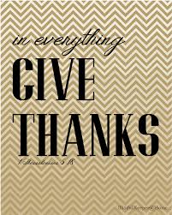

Agenda

- Warm-Up

Class Work: Aplia Application Problems 6-1, 6-2, 6-3, 6-4

Homework: Math Work Sheet

- Return Graded Work

- Return Ch. 1 Study Guide

- Return Chapter 1 Test

Warm-Up

True or False:

- Adjusting entries must be posted to the general ledger of accounts.

- The best way to
prevent errors is to use a calculator.



“It is never too late to be what you might have been.”
- G. Eliot

