Mr. Sabado, Accounting Week 16 Wednesday, December 6, 2017

Homework

Due Today:
A61: Aplia 6-1

Due 12/7
A61: Aplia 6-2, 6-3, 6-4

Chapter 6 Test on Tuesday, 12/12
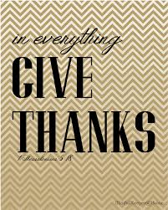

Agenda

- Warm-Up

Class Work: Extending Account Balances

Homework: Aplia 6-2, 6-3, 6-41

- Return Graded Work

- Return Ch. 1 Study Guide

- Return Chapter 1 Test

Warm-Up

True or False:

- Most errors occur
in doing arithmetic.

- If errors are
found in a work sheet, they must be erased and corrected before any further work is completed.



“It is never too late to be what you might have been.”
- G. Eliot

