Mr. Sabado, Accounting Week 16 Tuesday, December 5, 2017

Homework

Due Today:
A61: OYO 6-2

Due 12/6
A61: Aplia 6-1

Chapter 6 Test on Tuesday, 12/12
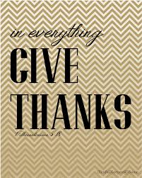

Agenda

- Warm-Up
-Read 6-4

Class Notes: Work Together 6-4

Class Work: Vocab 6-4

Homework: Aplia 6-1

- Return Graded Work

- Return Ch. 1 Study Guide

- Return Chapter 1 Test

Warm-Up

- What does
endorse mean?

- What is identity
theft?



“It is never too late to be what you might have been.”
- G. Eliot

