Mr. Sabado, Accounting Week 16 Monday, December 4, 2017

Homework

Due Today:
A61: OYO 6-2

Due 12/5
A61: OYO 6-3

Chapter 6 Test on Tuesday, 12/12
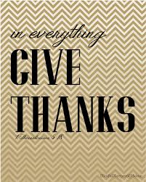

Agenda

- Warm-Up

-Read 6-3

Class Notes: Work Together 6-2

Homework: Vocab 6-2

- Return Graded Work

- Return Ch. 1 Study Guide

- Return Chapter 1 Test

Warm-Up

- In 4 months, Eric’s
parents will need to make the final payment for Eric’s braces. Half of the total cost was paid when his braces were put on. The total cost is $2,800. How much will Eric’s parents need to save each month to pay off the balance owed?
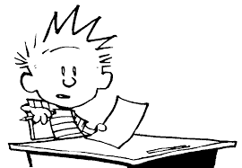

“It is never too late to be what you might have been.”
- G. Eliot

