Mr. Sabado, Accounting Week 17 Wednesday, December 13, 2017

Homework

Due Today:
A64: Chapter 6 Ethical Decision Making

Due 12/14
A65: Vocab 7.1 and OYO 7.1

Chapter 7 Test on Thursday, 12/21
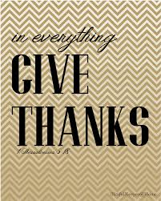

Agenda

- Warm-Up

-Read 7-1

Class Notes: Work Together 7-1

Homework:
Vocab 7.1 + OYO 7.1

- Return Graded Work

- Return Ch. 1 Study Guide

- Return Chapter 1 Test

Warm-Up

Write the following fractions rounded to the nearest hundredth.

1) $\frac{1}{\text{20}}$ 2) $\frac{2}{\text{18}}$

3) $\frac{2}{5}$ 4) $\frac{\text{17}}{\text{50}}$



“It is never too late to be what you might have been.”
- G. Eliot

