Mr. Sabado, Accounting Week 17 Monday, December 11, 2017

Homework

Due Today:
A63: Chapter 6 Activities

Due 12/12
-Finish Aplia Assignments
- Study for Test

Chapter 6 Test on Tuesday, 12/12
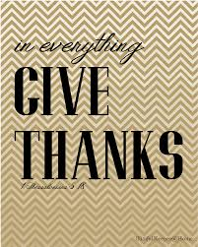

Agenda

- Warm-Up

Class Work: Pennies a Day

Homework:
Chapter 6 Activities
Finish Aplia Activities

- Return Graded Work

- Return Ch. 1 Study Guide

- Return Chapter 1 Test

Warm-Up

Write “No Warm-Up” in Monday’s box.

Complete Worksheet: Pennies a Day – Preview Questions



“It is never too late to be what you might have been.”
- G. Eliot

