Mr. Sabado, Accounting Week 15 Friday, December 1, 2017

Homework

Due Today:
A60: OYO 6-1

Due 12/1:
A61: OYO 6-2

Chapter 6 Test on Wednesday, 12/13
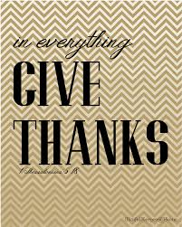

Agenda

- Warm-Up
- Turn in Opener Packet

-Read 6-2

Class Notes: Work Together 6-2

Homework: Vocab 6-2

- Return Graded Work

- Return Ch. 1 Study Guide

- Return Chapter 1 Test

Warm-Up

- Write No Warm-Up


“It is never too late to be what you might have been.”
- G. Eliot

