Mr. Sabado, Accounting Week 14 Tuesday, November 21, 2017

Homework

Due Today:
A56: Unit 1 Reflection
A57: Maya’s Spending Plan

Due 11/27:
No Homework

NEFE Test on Tuesday, 11/21
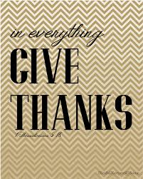

Agenda

- Warm-Up

- Unit 1 NEFE Test

- Quiet Activity

- Return Graded Work 

- Return Ch. 1 Study Guide

- Return Chapter 1 Test

Warm-Up

- Write No Warm-Up
- Turn in Week 14 Packet
- Turn in Unit 1 Reflection
- Take out a Calculator and Pencil
- Place all other belongings in the front of the class (including cell phone)
- Wait for further instructions

“It is never too late to be what you might have been.”
- G. Eliot

